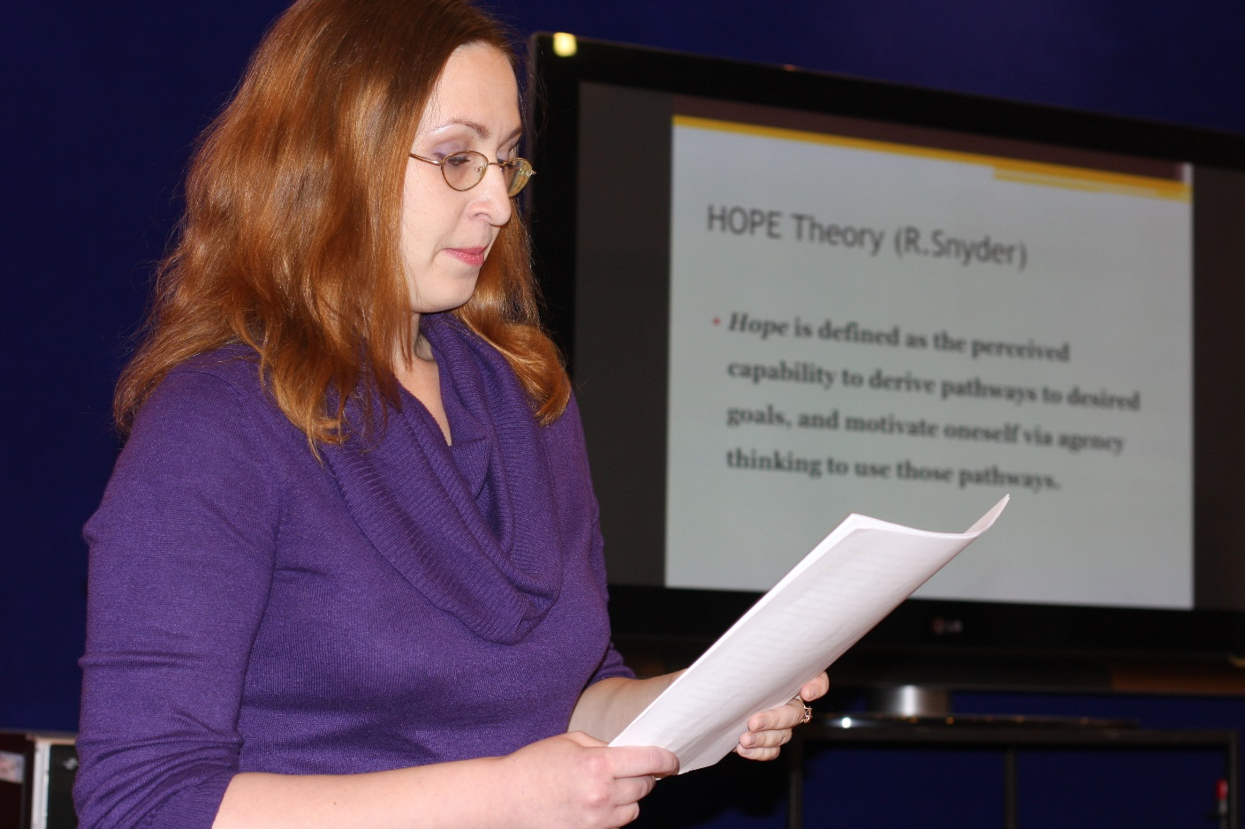
Valeria Potyavina (Russia, Saint Petersburg)

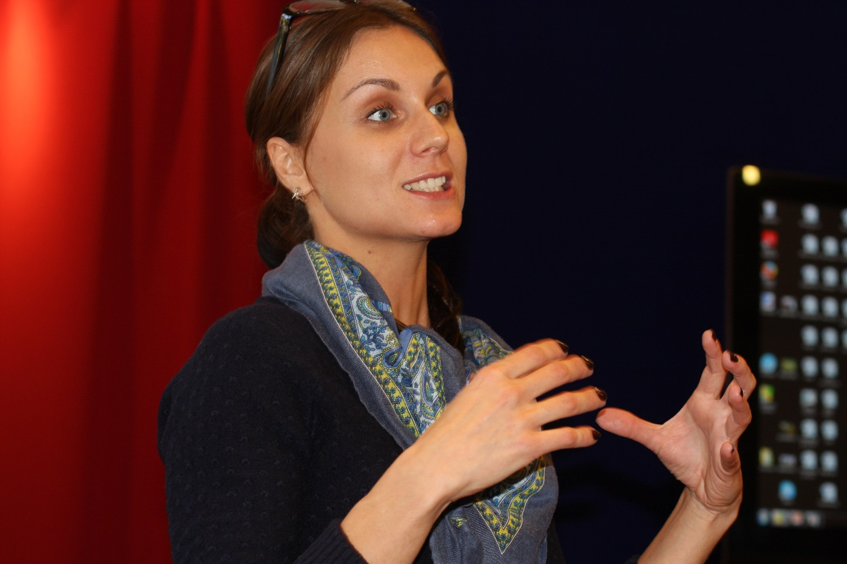
Inna Tsibulko (Ukraine, Kiev)
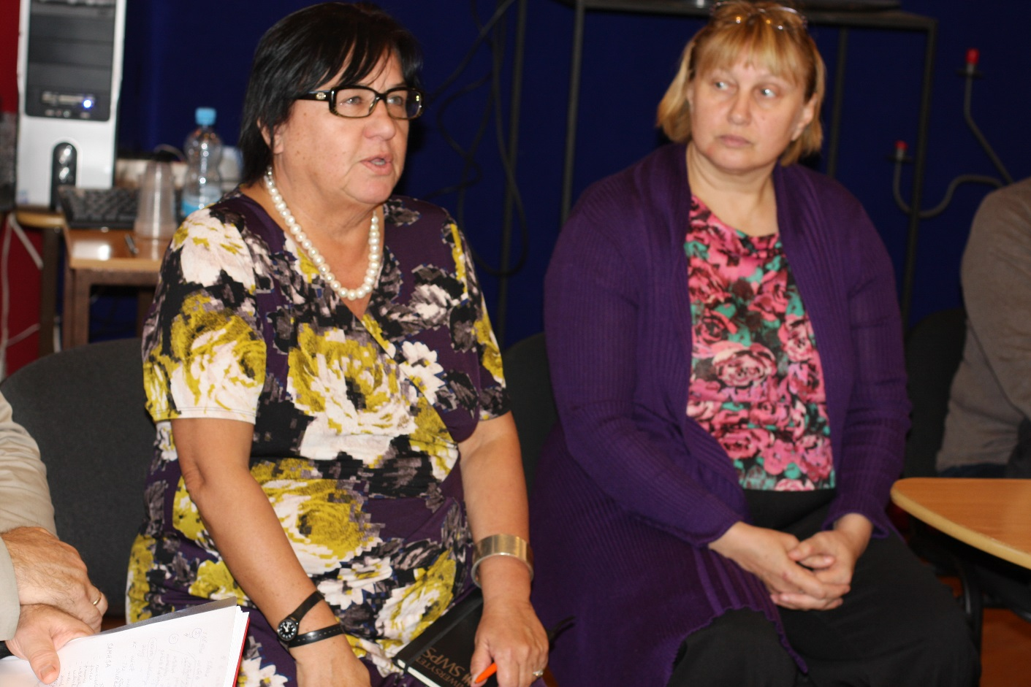
Teresa Gordocka (Poland, Warsaw) Viktoria Rubina (Estonia, Tallinn)
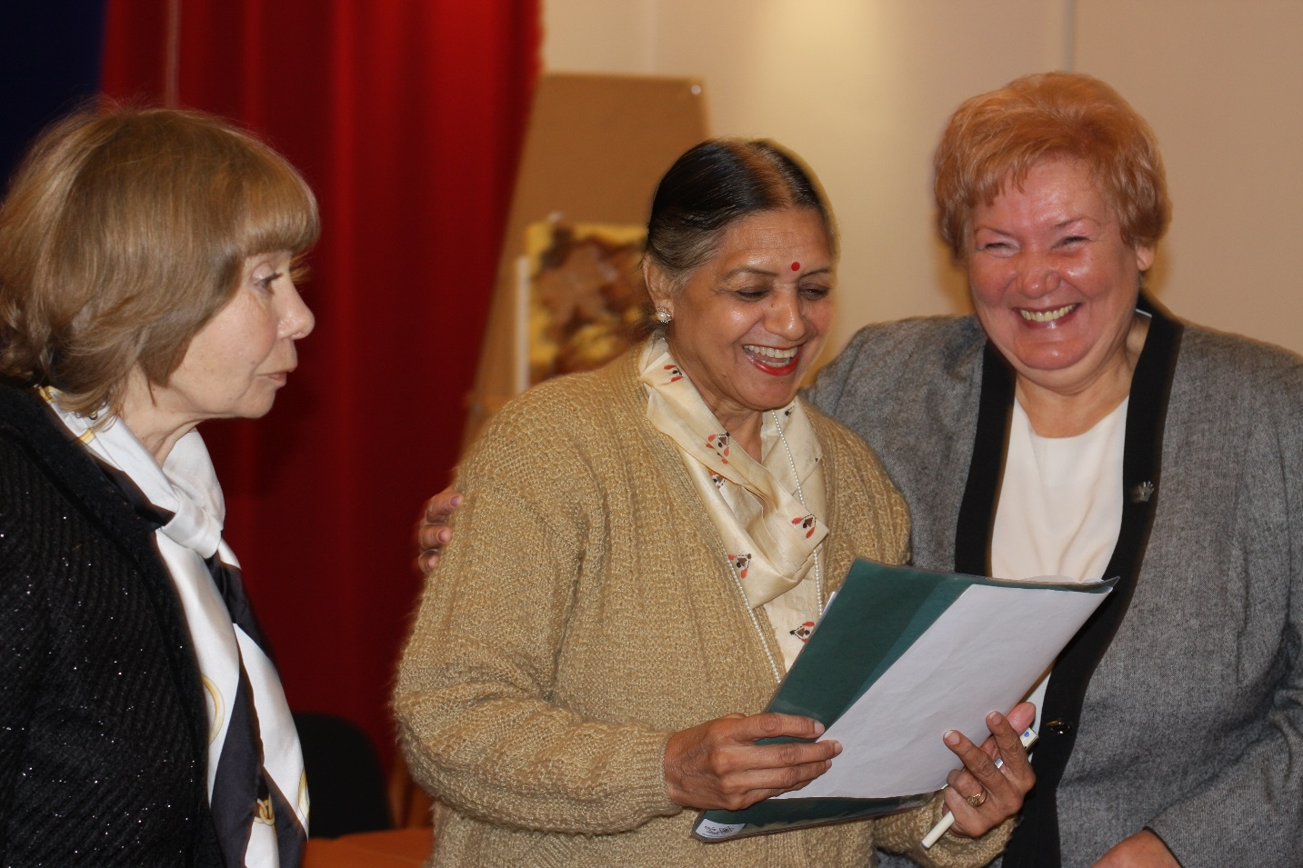
Ludmila Baranova Prabhjot Kulkarni Mara Vidnere
(Latvia, Riga) (India, Deli) (Latvia, Riga)

