International participants  Leila Peseschkian, Katerina Ovcharek, Polina Meshkova, Yekaterina Kadetova, Galina Monina, Valeriy Afanasyev, Sergey Petrushin, Inna Pishinskya, Nataliya Rediskina, Victoria Rubina  Date: September 8-10, 2017  September 8, 16.00-20.00. Coffee break at 18.00.  September 9, 10.00-17.00. Lunch: 13.00 - 14.00.  September 10 - Cultural program.  Venue: International Higher School of Practical Psychology (Latvia, Riga, 65 Bruninieku Street).  Cultural program:  - Visiting art exhibitions (National Art Museum, "Birzha", Museum of Decorative Art and Design, ...).  - Visiting the Dome Cathedral,  - City Tour,  - Visiting Jurmala or the Campus of the International Higher School of Practical Psychology.  Participants of the Summer University receive certificates for their work at the international conference. The main contribution of the participants is a presentation, a master class, participation in the work of the "round table", an article for publication.  Materials for publication are accepted until August 15, 2017 by email ihspp@sppa.lv, sppa@sppa.lv.  Organizing Committee | 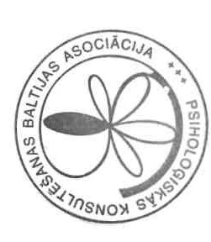  Additional information  can be obtained at:  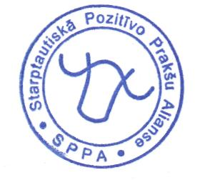  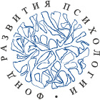  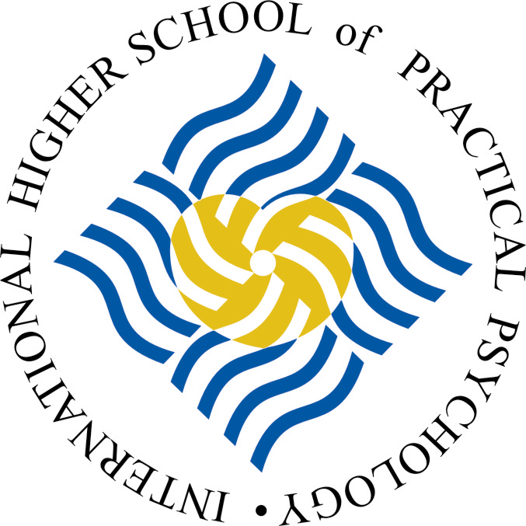  The Fund of Development of Psychology | Baltic Association for  Psychological Counselling  Center for Positive and Transcultural Psychotherapy  in Baltic States  International Higher School of  Practical Psychology
  Arrangement of Conference
  65 Bruninieku Street, Riga, LV-1011
  The Secretariat -
  Larisa Korolchuk
  Tel: + 371-67506257
  e-mail: ihspp@sppa.lv
  janis_m@sppa.lv
Metaphorization and transcultural approach in counselling and psychotherapy

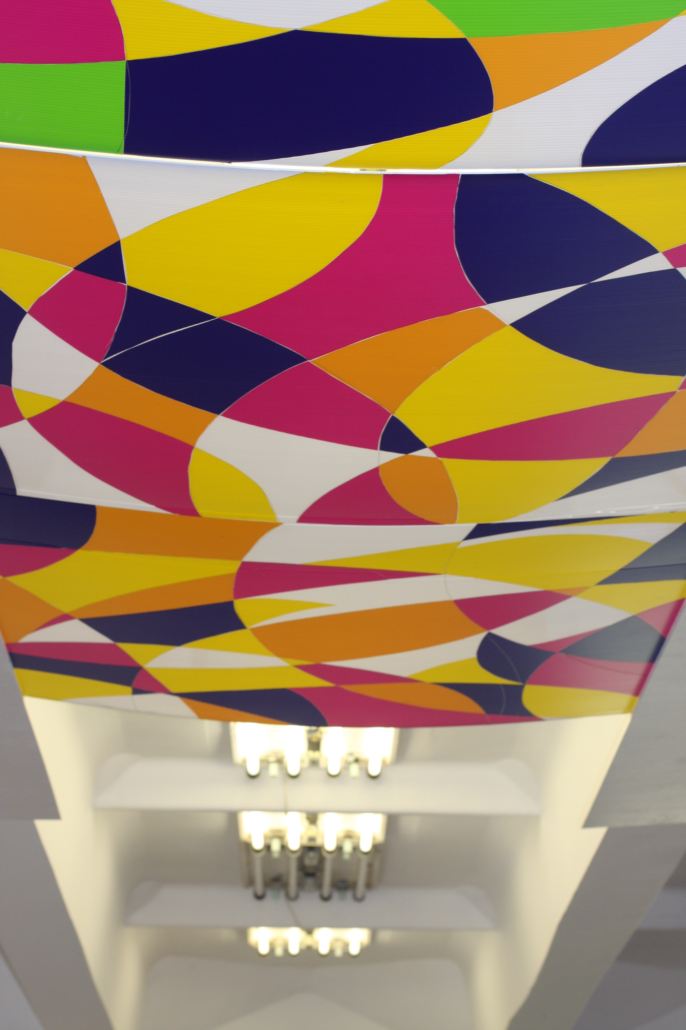

XXX International Summer University

8 - 10 September 2017
Riga, Latvia
Both theoretical and practical work requires tools - in one case - for collecting, processing, analyzing, interpreting data, in another case - for constructive development of the process of dialogue, its progress towards the goal set by the client himself, the desired result.  In humanistic-oriented counseling and psychotherapy, the image, metaphor, example, sample, or one or another cultural matrix are used as a method or way of work.  This enables :  A) you to consider as a whole the emotional and rational aspects of internal conflict (which are not always fully realized),  B) the client himself to see the topic, the problem, the complaint, the desire, the way of moving to higher quality of life in a more generalized form and, therefore, to distance himself from the emotionally "hot" situation,  C) to discover new associative links and, in connection with this, new resource states.  The methodological basis of the work is Positive and Transcultural psychotherapy.  - image,  - metaphor,  - comparison,  - example,  - sample,  - tradition | - Possibilities of metaphorization and transcultural approach in the development of the process of counseling and psychotherapy of client.  - Specificity of metaphorization and transcultural approach in different forms of image building (verbal, visual, audial, kinesthetic and motor, proximic, ...) and at different levels of mediation in the context of one's or another culture (family, friends, authoritative people from the fields of education, culture, sport, business, characters of literary works or movies, charismatic personalities, "gurus", sages, ...).  - Specificity of metaphorization and transcultural approach at different stages ("steps") of counseling, psychotherapy.  - Exchange of ideas and developments with colleagues from different countries and with different work experience,  - Specification of the basic concepts based on a review of relevant literature,  - Conducting master classes demonstrating the capabilities of these methods,  - Preparation of a collection of publications,  - Establishment of professional contacts for the development of research, educational and practical-oriented international projects. | • Reports (20 - 25 minutes),  • Issues, discussions (5-10 min),  • Master classes: consultations (90 min.),  • Discussion (30-40 min.),  • Creative workshops (30 - 40 min.),  • "Round table" on one of the problematic issues.  Active participants who submitted materials for reports and publications are provided with free meals and accommodation. Other participants pay participation in the conference in the amount of 25 euros.  Based on the materials of the reports, a collection of articles is prepared. For publication, the author's materials are accepted in Russian, which do not require any significant modifications.  The font of the article is Times New Roman, the margins are on the left: 3 cm / on the right 1.5 cm / at the top and bottom 2 cm.  The length of the article: 5 - 6 pages, including a list of references and an abstract in English.  The title of the article (14 pt., Bold, Caps Lock) - center alignment.  Name and surname of the author (14 pt, Bold) - right alignment.  On the next line - the full name of the organization, followed by the indication of the country, the city in parentheses (12 pt, Italic) - right alignment.  Text (12 pt, Normal) - aligns to the width.  Line spacing (1.15)  Indentation (1.25 cm)  Tables, charts, references (10 pt, Normal)
  Scientific rationale
  Key words
  Themes of Conference
  Objectives of the Conference
  Forms and working hours
  Requirements for the publication

