Forms and working hours  - Reports (20 - 25 minutes),  • Issues, discussions (5-10 min),  • Master classes (90 min.),  • Discussion (30-40 min.),  • Creative workshops (30 - 40 min.),  • "Round table" on one of the problematic issues.  Date: 15-16 June 2018.  15 June 16.00-20.00. Coffee break at 18.00.  16 June 10.00-13.00.  16 June at 14.00 – going out into nature / cultural program.  Venue: International Higher School of Practical Psychology (Latvia, Riga, 65 Bruninieku Street).  Cultural program:  - Visiting art exhibitions (National Art Museum, Riga Bourse, Museum of Decorative Art and Design, ...).  - Visiting the Riga Dome Cathedral,  - City Tour.  Active participants receive certificates for work in the festival and are provided with accommodation. The main contribution of the participants is a presentation, a workshop, participation in the work of the "round table", an article for publication.  Materials for publication are accepted until June 10, 2018 by email ihspp@sppa.lv, sppa@sppa.lv.  Organizing Committee | 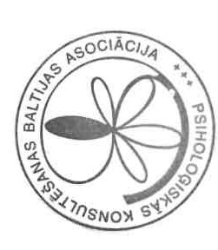  Additional information  can be obtained at:    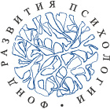    The Fund of Development of Psychology | Center for Positive and Transcultural Psychotherapy in the Baltic States  Baltic Association for  Psychological Counselling  International Higher School of  Practical Psychology
  Arrangement of Festival
  65 Bruninieku Street, Riga,
  LV-1011, Latvia
  The Secretariat -
  Larisa Korolchuk
  Tel: + 371-67506257
  e-mail: ihspp@sppa.lv
  janis_m@sppa.lv
Festival of psychological stories

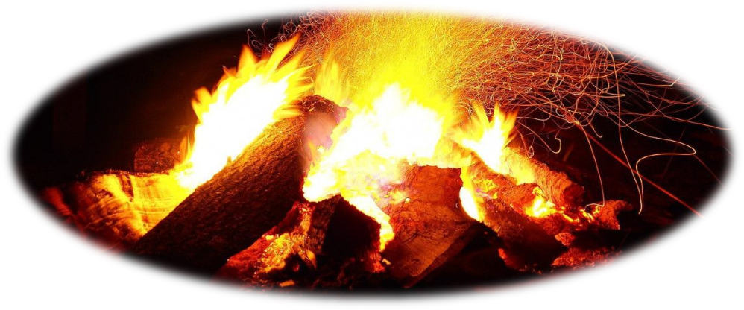

15 – 16 June 2018

Riga, Latvia

Alternative Academy of Third Age
Festival of psychological stories again  There are events of private life about which there is a wish to tell others, and there are problem situations which demand the description, discussion, comprehension. And those, and other situation - events may be presented as psychological phenomena, "time quanta", "psychological stories". They can be interesting in themselves or can become a subject of a further psychological research, the analysis, if to record them. The problem is that the "stories" (as events of private life) should be "caught" (seen, found, remembered), "made" (described in an interesting way) and given a short analysis from a position of the consultant or the psychotherapist.  Description of stories:  • First of all, it is a separate episode from private life which happened at a certain time ("once...") and in a certain place.  • The described event according to the contents is interesting to Another, - it can cause in the listener (or the reader) some splash of emotions.  • There are some contradictions, misunderstanding, or, probably, a conflict in the story which demand comprehension. It is a "case"... | At the Festival the following reports are assumed:  - about art of remembering vital events ("story") and about episodes of the creative biography of the famous psychotherapists ("the Master's Method"),  - about value of "life stories" in maintenance and strengthening of psychological health of the person ("a narrative in psychotherapy"),  - about narrative contents of visual messages ("photo language", comics...).  The main contents is the attempt of return to traditions of the Renaissance (Boccaccio, Chaucer, Margaret of Navarre...), - namely - the story (maybe, near a bonfire) about wonderful, unusual, mysterious, contradictory... events of private life, - subjects which can interest listeners and which are important for understanding of implications and paradoxes of psychological human life...  Methodological basis of preparation of the collection of "stories" is the phenomenological aspect of Positive Psychotherapy (N. Peseschkian).  - Exchange of ideas and developments with colleagues from different countries and with different work experience.  - Specification of the basic concepts based on a review of relevant literature. | - Conduction of master classes demonstrating the capabilities of these methods.  - Preparation of a collection of publications.  - Establishment of professional contacts for the development of research, educational and practical-oriented international projects.  Based on the materials of the reports, a collection of articles is to be prepared. For publication, the author's materials are accepted in Russian, which do not require any significant modifications. Two types of publications are offered: scientific articles on a subject of the Festival and psychological stories.  The font of the article is Times New Roman, the margins are on the left: 3 cm / on the right 1.5 cm / at the top and bottom 2 cm.  The length of the article: 5 - 6 pages, including a list of references and an abstract in English.  The length of the stories: 3 pages.  The title of the article (14 pt., Bold, Caps Lock) - center alignment.  Name and surname of the author (14 pt, Bold) - right alignment.  On the next line - the full name of the organization, followed by the indication of the country, the city in parentheses (12 pt, Italic) - right alignment.  Text (12 pt, Normal) - aligns to the width.  Line spacing (1.15)  Indentation (1.25 cm)  Tables, charts, references (10 pt, Normal).
  Scientific rationale
  Objectives of the Festival
  Requirements for the publication

