Possible International participants  Leyla Peseschkian, Kateryna Ovcharek, Polina Meshkova, Ekaterina Kadetova, Valeriy Afanasyev, Sergey Petrushin, Inna Pishinskya, Nataliya Rediskina, Victoria Rubina, …  Date: February 02-04, 2018  February 2, 16.00-20.00. Coffee break at 18.00.  February 3, 10.00-17.00. Lunch: 13.00 - 14.30.  February 4 – cultural program.  Venue: International Higher School of Practical Psychology (Latvia, Riga, 65 Bruninieku Street).  Cultural program:  - Visiting art exhibitions (National Art Museum, "Birzha", Museum of Decorative Art and Design, ...).  - Visiting the Dome Cathedral,  - City Tour.  Active participants receive certificates for work in the international conference and are provided with accommodation. The main contribution of the participants is a presentation, a workshop, participation in the work of the "round table", an article for publication.  Materials for publication are accepted until January 10, 2018 by email ihspp@sppa.lv, sppa@sppa.lv.  Organizing Committee |   Additional information  can be obtained at:        The Fund of Development of Psychology | Center for Positive and Transcultural Psychotherapy in the Baltic States  Baltic Association for  Psychological Counselling  International Higher School of  Practical Psychology
  Arrangement of Conference
  65 Bruninieku Street, Riga,
  LV-1011, Latvia
  The Secretariat -
  Larisa Korolchuk
  Tel: + 371-67506257
  e-mail: ihspp@sppa.lv
  janis_m@sppa.lv
Balance Model in different psychological directions and psychotherapeutic practices

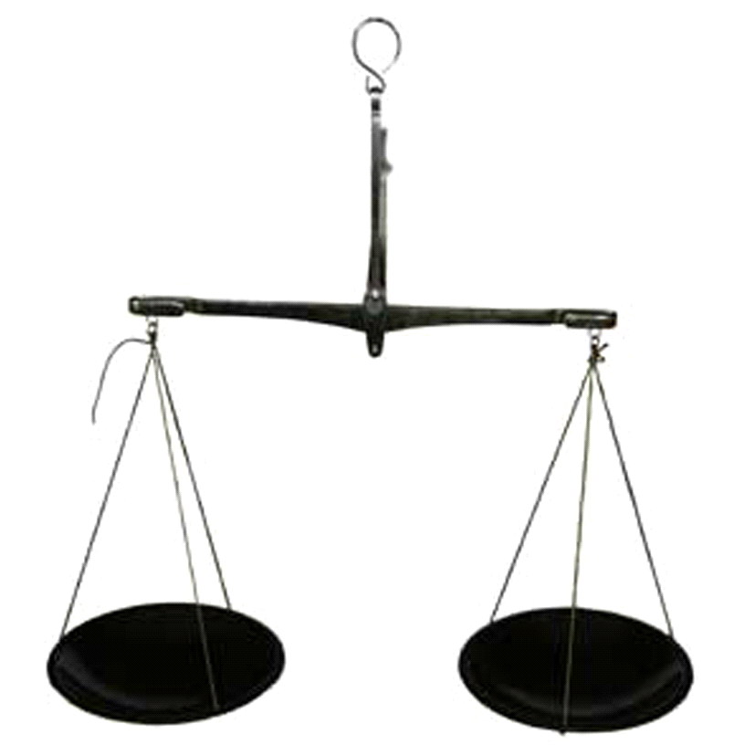

International Conference

2 – 4 February 2018

Riga, Latvia
To record and understand some phenomenon – it is necessary to see it in the context of other phenomena. It belongs as to physical objects, and theoretical models.  The most productive idea of balance in the positive and transcultural psychotherapy is not an exception. Its advantage is most brightly shown against the background of other concepts.  In the conference it is supposed:  1. Theoretical study and discussion of balance models in different medical, psychological and psychotherapeutic approaches, directions, concepts.  2. An empirical research of balance model in different groups of people: with the different organization of lifestyle, at people of different professional works, age, state of health.  3. Development of individual cards of balance at different strategies of development and different types and levels of conflict situations.  Based on the materials of the reports, a collection of articles is prepared.  - Balance model,  - lifestyles,  - valuable orientations,  - conflict situations,  - development strategies. | - Historical review, - The East – the West  - Balance model in a transcultural discourse  - Quantitative and qualitative indicators of separate parameters of balance model  - Display of “balance” by people of different types of activity, age, state of health  - A subjective position and objective indicators by people with different lifestyles and valuable orientations  - Balance model in different styles of the organization of private life  - Exchange of ideas and developments with colleagues from different countries and with different work experience,  - Specification of the basic concepts based on a review of relevant literature,  - Conducting master classes demonstrating the capabilities of these methods,  - Preparation of a collection of publications,  - Establishment of professional contacts for the development of research, educational and practical-oriented international projects. | - Reports (20 - 25 minutes),  • Issues, discussions (5-10 min),  • Master classes (90 min.),  • Discussion (30-40 min.),  • Creative workshops (30 - 40 min.),  • "Round table" on one of the problematic issues.  Based on the materials of the reports, a collection of articles is prepared. For publication, the author's materials are accepted in Russian, which do not require any significant modifications.  The font of the article is Times New Roman, the margins are on the left: 3 cm / on the right 1.5 cm / at the top and bottom 2 cm.  The length of the article: 5 - 6 pages, including a list of references and an abstract in English.  The title of the article (14 pt., Bold, Caps Lock) - center alignment.  Name and surname of the author (14 pt, Bold) - right alignment.  On the next line - the full name of the organization, followed by the indication of the country, the city in parentheses (12 pt, Italic) - right alignment.  Text (12 pt, Normal) - aligns to the width.  Line spacing (1.15)  Indentation (1.25 cm)  Tables, charts, references (10 pt, Normal)
  Scientific rationale
  Key words
  Themes of Conference
  Objectives of the Conference
  Forms and working hours
  Requirements for the publication

